EXPERIMENT 4.1: Implement Classification Model Using KNN and Compute Evaluation Metrics

Aim: To implement a K-Nearest Neighbors (KNN) classification model to predict students' results and evaluate its performance using classification metrics.

Algorithm:
- Import Pandas and the required Scikit-learn modules.
- Load the dataset from data.csv.
- Select Hours_Studied, Attendance, and Assignments as input features.
- Select Result as the target variable.
- Split the dataset into training and testing sets in an 80:20 ratio.
- Create a KNN classifier with n_neighbors=3.
- Train the model using the training data.
- Predict the results for the testing data.
- Calculate and display accuracy and the confusion matrix.
- Display the classification report containing precision, recall, and F1-score.
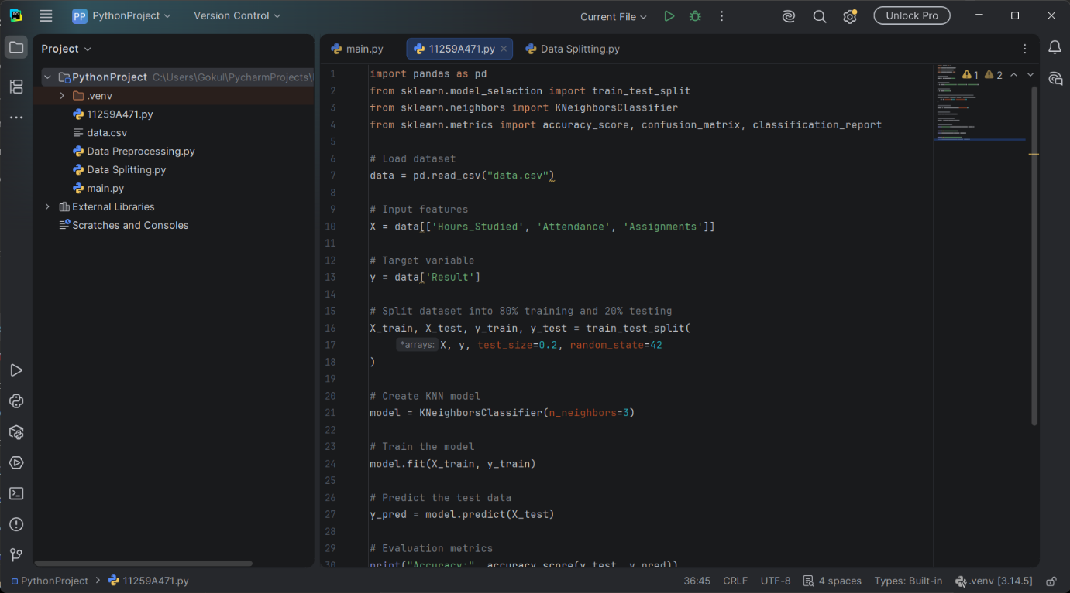

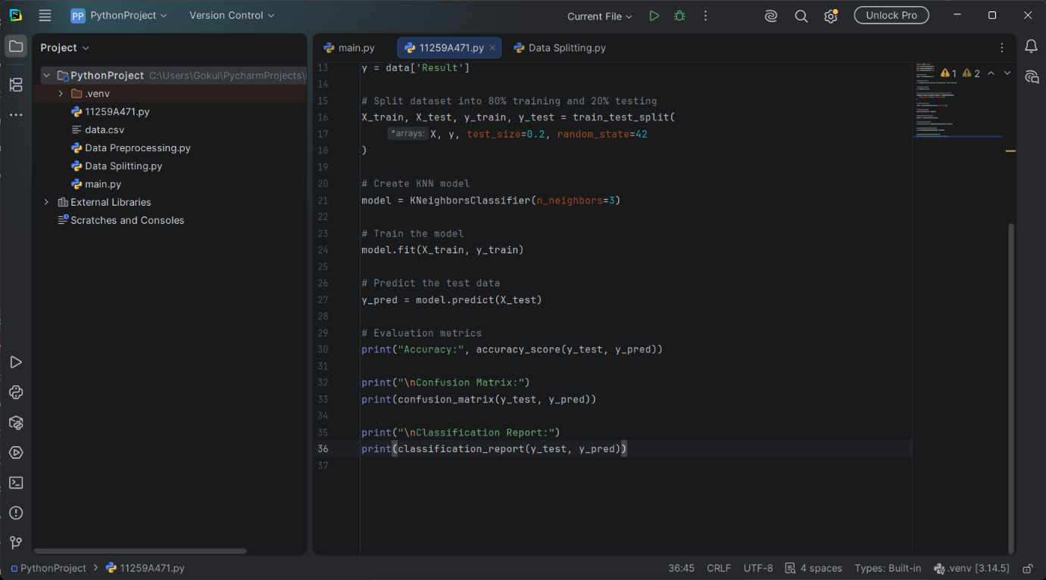
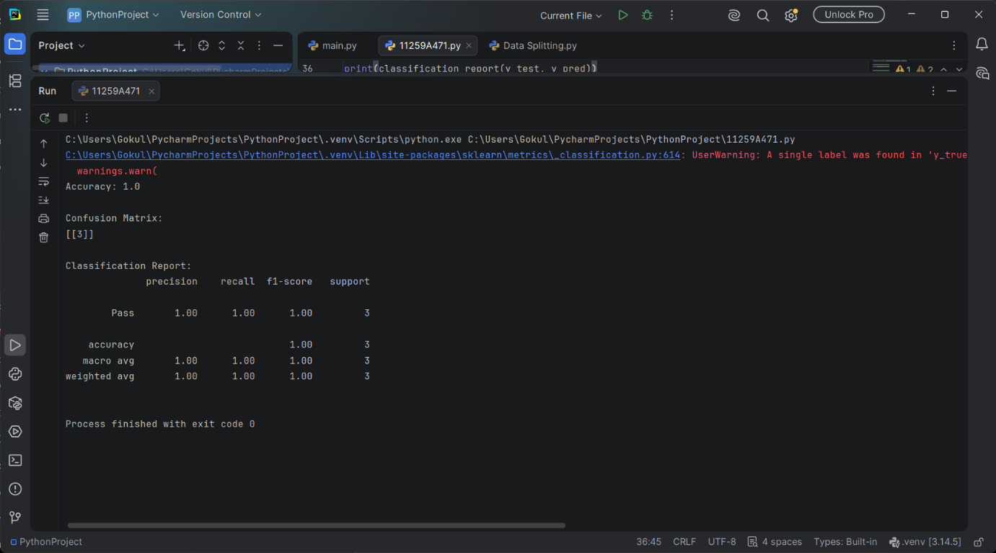

RESULT:
The KNN classification model was successfully implemented, and its performance was evaluated using accuracy, the confusion matrix, and the classification report.

